***5 Marks QNS***

**1. Explain steps in Fuzzy Inference System**

The Fuzzy Inference System (FIS) is a framework for reasoning and decision-making with fuzzy logic. The FIS typically involves five main steps:

1. **Fuzzification**

- In this initial step, crisp (numerical) input values are transformed into fuzzy sets. Each input variable is mapped to a degree of membership in one or more fuzzy sets, which describe possible values of the variable (e.g., "low," "medium," "high").

- Membership functions define how each input value maps to these fuzzy sets, typically using shapes like triangular, trapezoidal, or Gaussian functions.

2. **Rule Evaluation (Inference)**

- In this step, a set of fuzzy if-then rules, defined by experts, is applied to the fuzzified inputs. Each rule generally has the format: "If *input1* is *low* and *input2* is *high*, then *output* is *medium*."

- The rules use fuzzy operators (like AND, OR) to combine the inputs according to each rule’s conditions, producing an output fuzzy set for each rule.

3. **Aggregation of Rule Outputs**

- Once each rule produces a fuzzy output, the results of all rules are combined or aggregated. This step gathers the fuzzy outputs from each rule to form a single fuzzy set representing the overall output of the FIS.

- Common aggregation methods include taking the maximum (max) or sum (sum) of the outputs.

4. **Defuzzification**

- In this step, the aggregated fuzzy output is converted back into a crisp value to provide a final numerical result or decision.

- Popular defuzzification methods include the Centroid (Center of Gravity) method, Bisector method, and Mean of Maximum (MoM).

5. **Output**

- The defuzzified crisp output is then presented as the final result of the FIS, which can be used for decision-making or control actions.

These steps allow a Fuzzy Inference System to make complex, human-like decisions based on imprecise input data.

Ye architecture hai lekin imp hai toh rehne de:

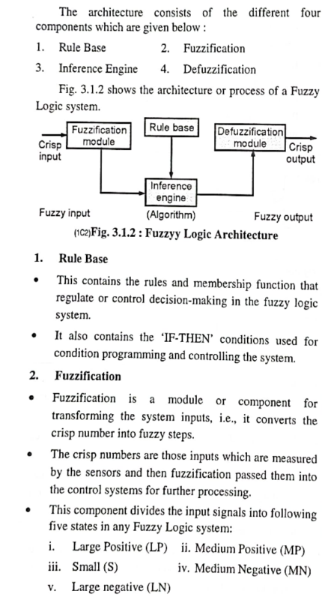

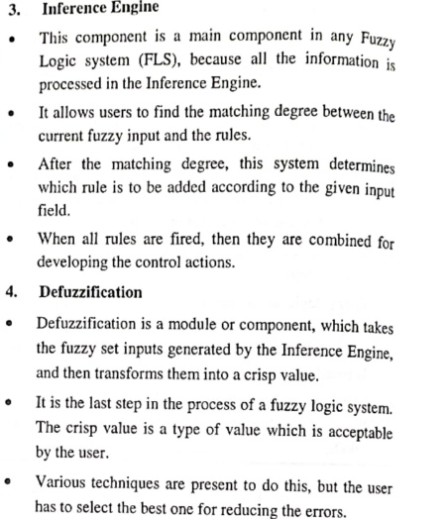

**2. How to compare classifiers based on cost benefit and ROC Curve ?**

To compare classifiers based on cost-benefit analysis and ROC (Receiver Operating Characteristic) curves, consider the following approaches:

### 1. Cost-Benefit Analysis

* Define Costs and Benefits: Identify the costs and benefits associated with true positives (TP), false positives (FP), true negatives (TN), and false negatives (FN). This might include financial costs, time, or risk factors associated with misclassification.
* Create a Cost Matrix: Structure a matrix showing the costs and benefits for each type of classification (TP, FP, TN, FN). For example:
  + True Positive (TP): Benefit of correctly identifying a positive case.
  + False Positive (FP): Cost associated with incorrectly identifying a negative case as positive.
  + True Negative (TN): Benefit or neutral value for correctly identifying a negative case.
  + False Negative (FN): Cost of missing a positive case, which can be high if it has severe consequences.
* Calculate Expected Cost: Using the classifier’s confusion matrix and cost matrix, calculate the expected cost for each classifier. The classifier with the lowest expected cost is generally preferred.
* Example Calculation:

### 

### 2. ROC Curve Analysis

* Plot the ROC Curve: For each classifier, plot the True Positive Rate (TPR) against the False Positive Rate (FPR) at various threshold levels. The curve shows the trade-off between sensitivity and specificity.
* Calculate the Area Under the ROC Curve (AUC-ROC): The AUC-ROC represents the probability that a randomly chosen positive instance is ranked higher than a randomly chosen negative instance. An AUC closer to 1 indicates a better-performing model.
* Compare ROC Curves:
  + Higher AUC: Prefer classifiers with a higher AUC value as they have better overall performance across thresholds.
  + Curve Shape: A curve closer to the top-left corner indicates a better balance between TPR and FPR. If one classifier’s ROC curve consistently lies above another’s, it is generally the better classifier.
* Select Threshold Based on Business Goals: The optimal threshold may differ depending on cost considerations or acceptable error rates for the application. You can select a threshold to balance cost and benefit based on the specific trade-offs.

### Integrating Cost-Benefit with ROC Curve

* Determine Optimal Threshold Using Cost-Benefit: For each classifier, find the threshold that maximizes net benefit or minimizes expected cost. This is done by adjusting the threshold along the ROC curve until the desired balance of TPR and FPR is reached.
* Combine Metrics: Consider both the AUC-ROC and the cost-benefit matrix to evaluate classifiers holistically. A classifier with a high AUC but also high cost for FP or FN may not be suitable if cost-sensitive decisions are crucial.

By combining cost-benefit analysis with ROC curve insights, you can select a classifier that not only performs well statistically but is also aligned with your specific cost and benefit objectives.

**3. In a certain locality, 90% children were failing sick due to flu and 10% due to measles and no other disease. The probability of observing rashes for measles is 0.95 and for flu is 0.08. If a child develops a rashes, find the child’s probability of having flu.**

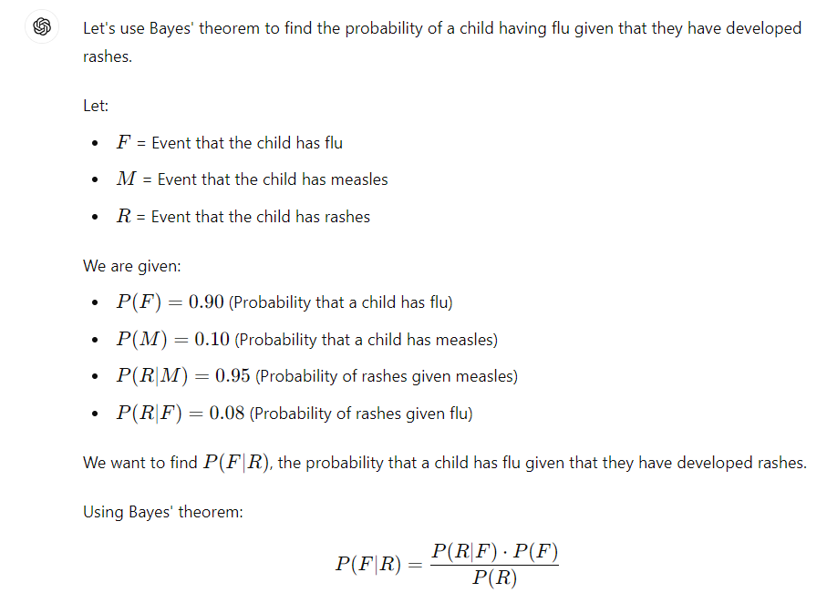

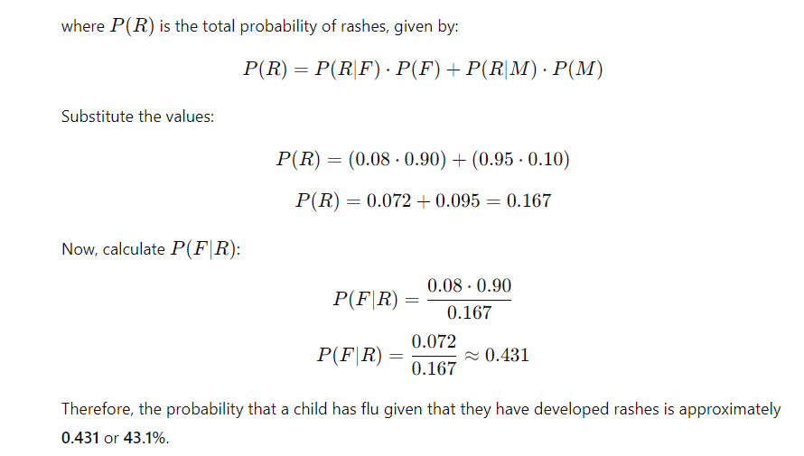

**4. What is the activation function and its need in a Neural Network?**

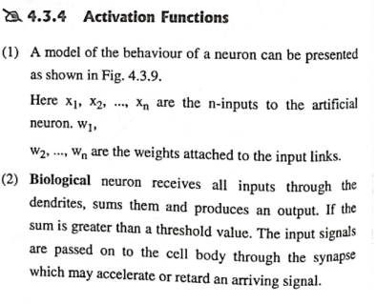

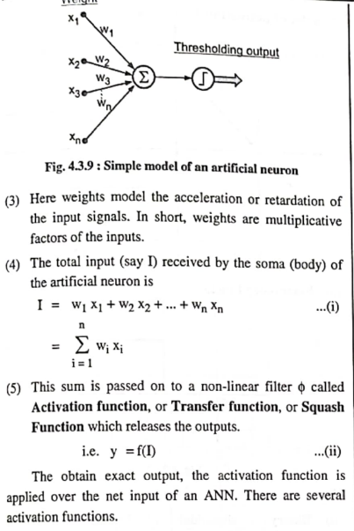

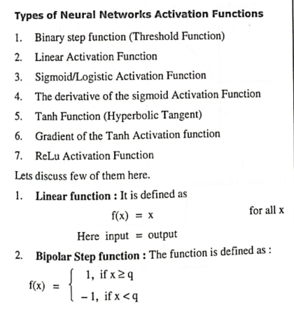

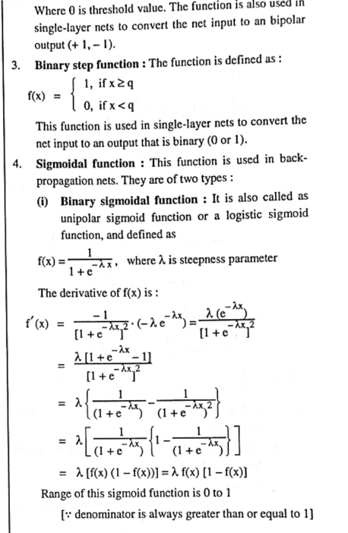

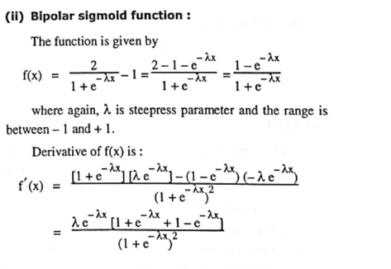

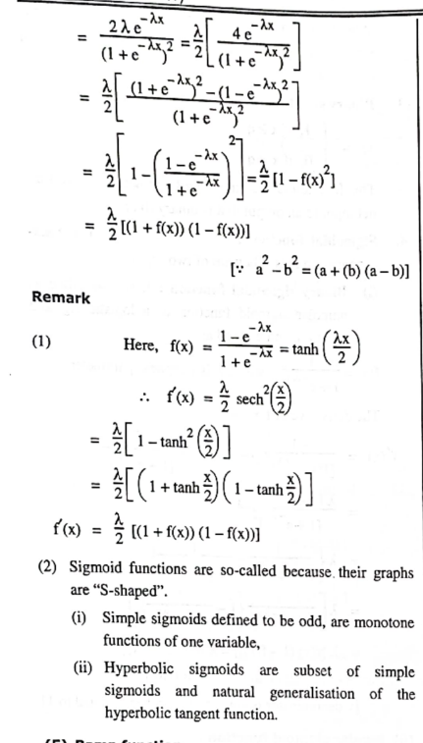

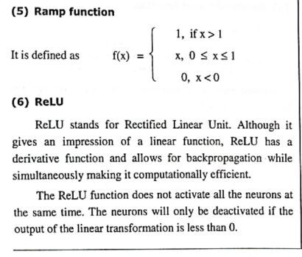

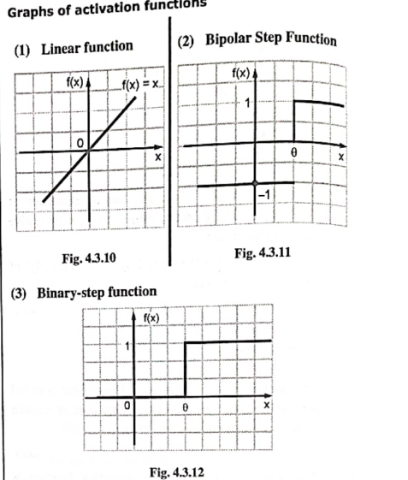

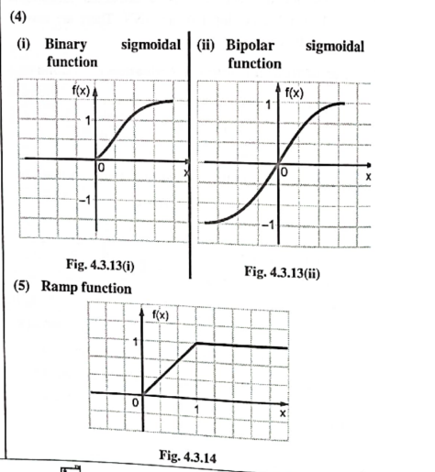

**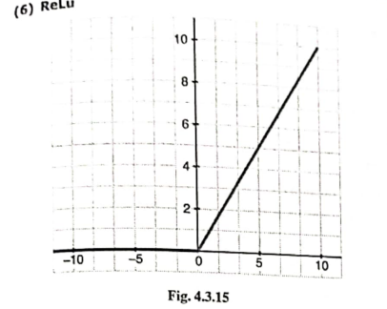  
  
5. Explain Max-Min and Max-Product Composition relation with suitable example?**

**6. Compare Feed Forward Network and Feedback Network? (Ye techNeo mein exact same nai mil raha )**

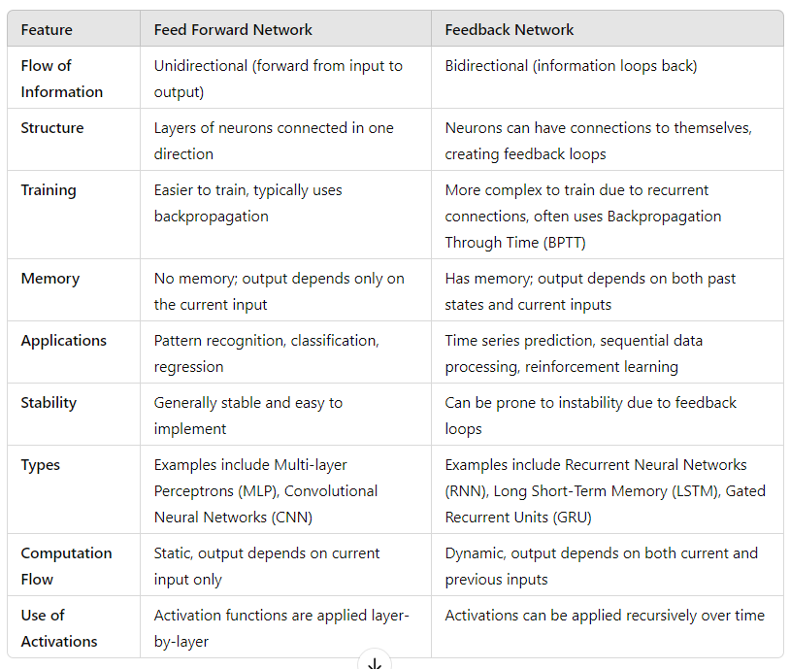

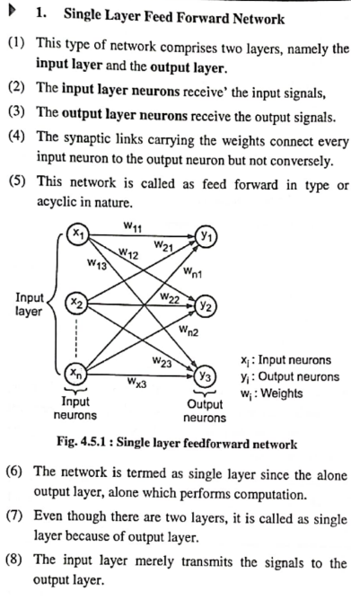

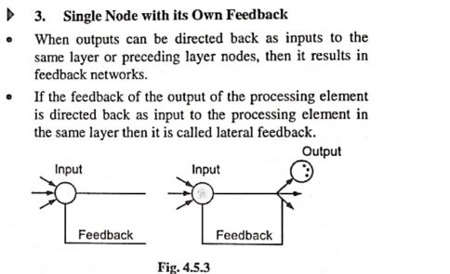

**7. Explain 3 Gates used in LSTM networks?**

**Forget Gate**: Determines which information from the previous cell state should be discarded or "forgotten."

**Input Gate**: Decides which new information should be stored in the cell state.

**Output Gate**: Controls how much of the cell state should be output to the next layer or time step.

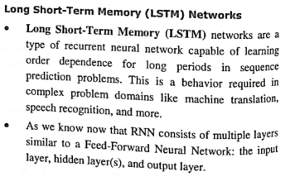

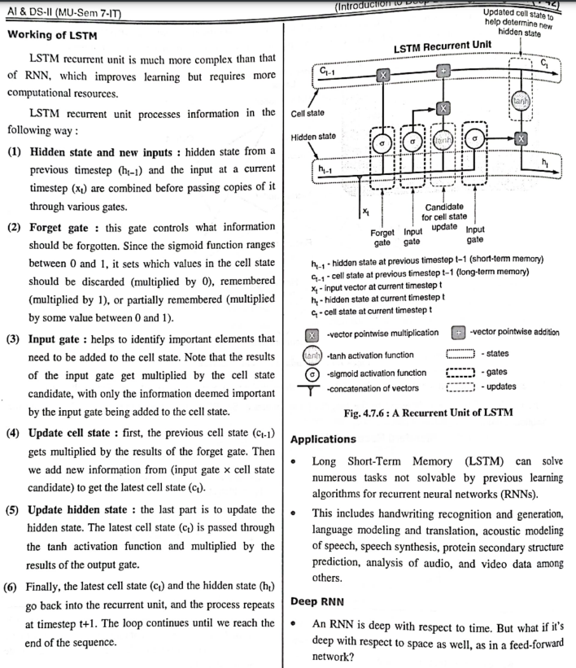

**8. Explain Cross Validation technique for Accuracy improvement?**

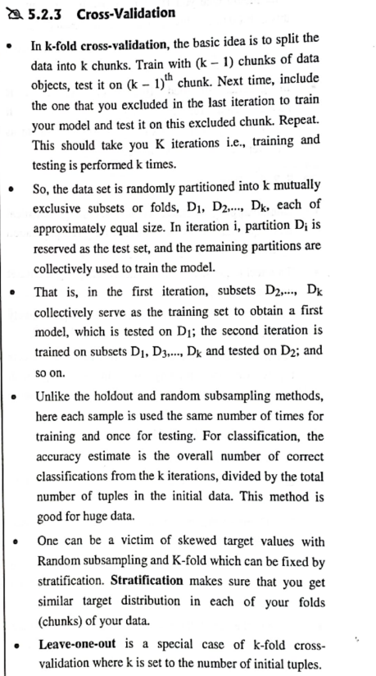

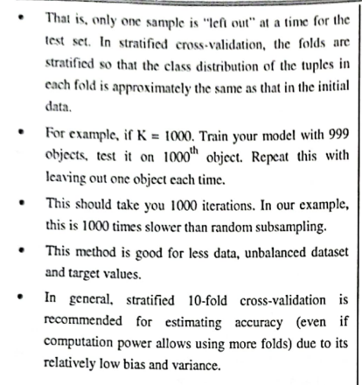

**9. Comment on "The Multimodal application of data science"**

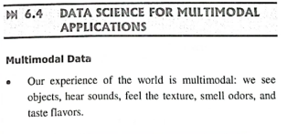

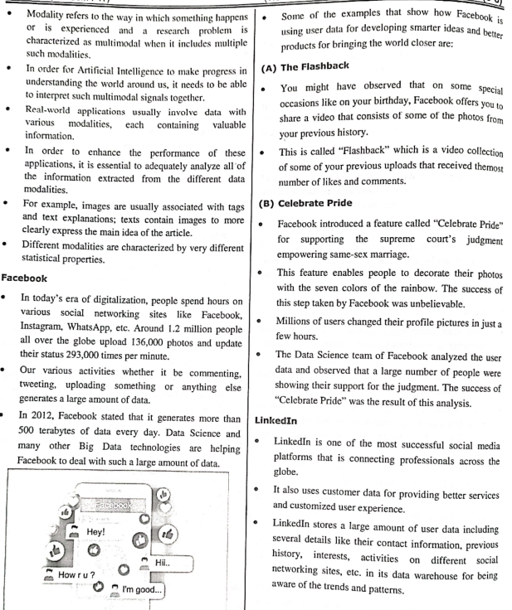

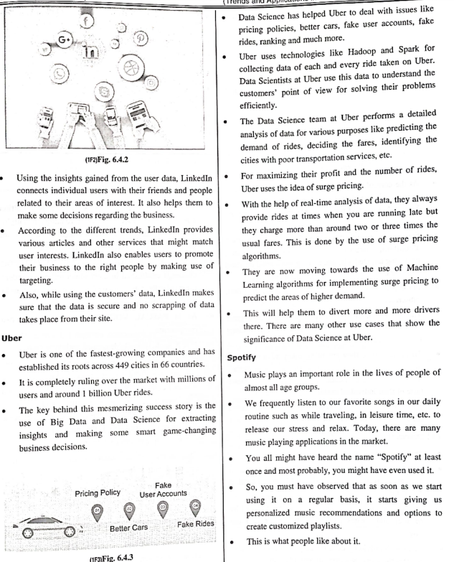

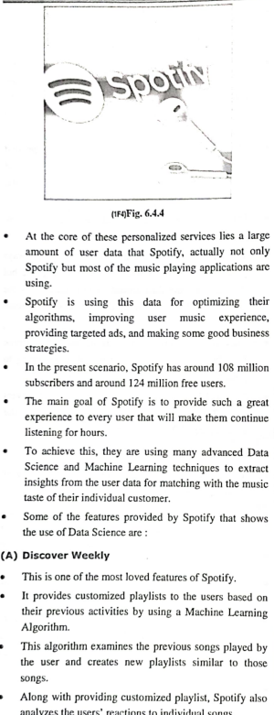

**10. Write short notes on Auto Encoders?**

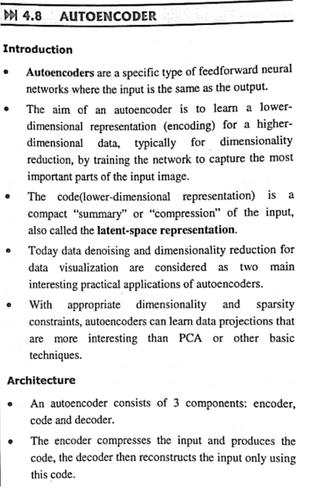

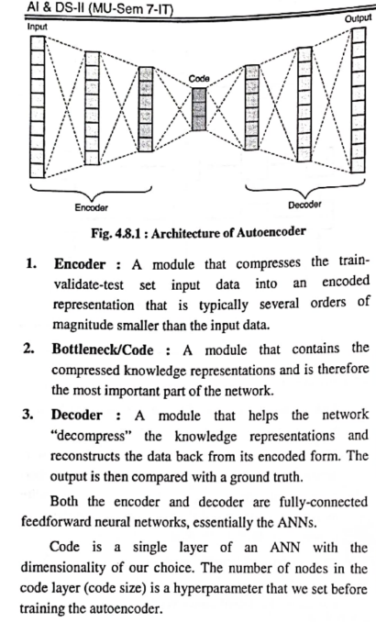

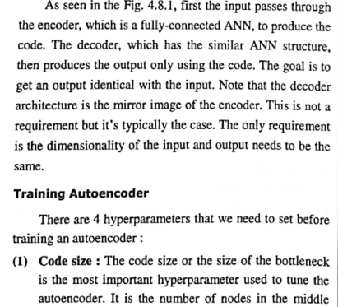

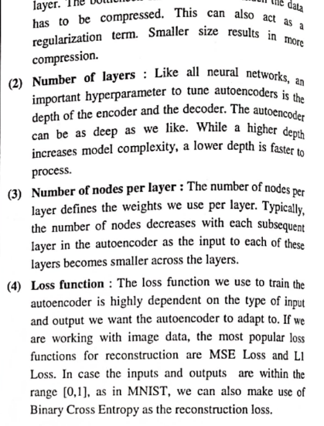

**11. Write short notes on Markov Decision Process?**

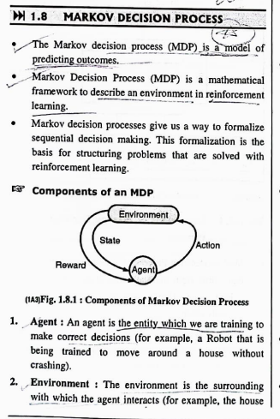 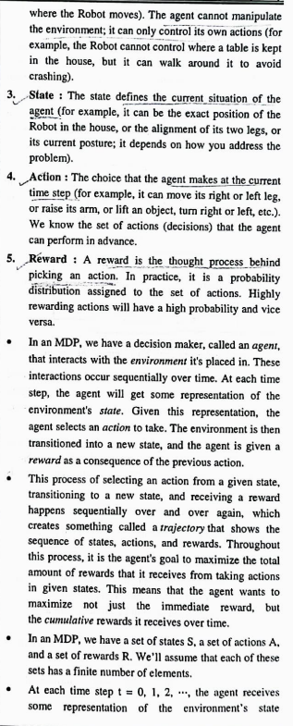

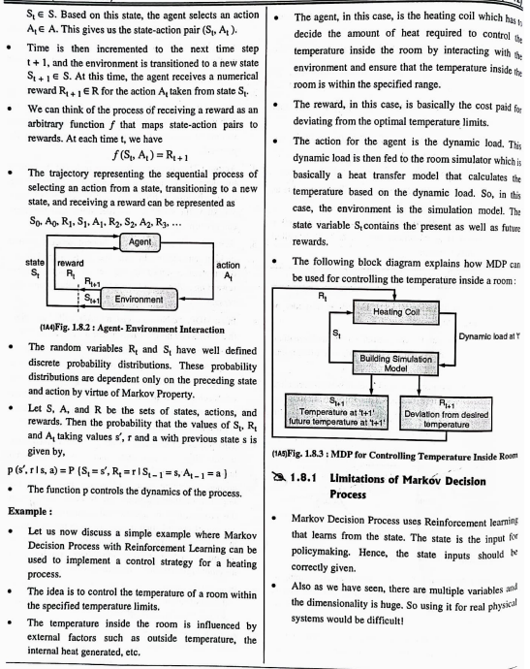

**12. What do you understand by Sentiments analysis and what are its application?**

**Sentiment Analysis** is a natural language processing (NLP) technique used to determine the emotional tone or sentiment expressed in text. It involves analyzing written content (such as reviews, social media posts, or articles) to identify whether the sentiment is positive, negative, or neutral. Sentiment analysis uses machine learning, deep learning, or rule-based methods to interpret subjective information in text data, allowing businesses and researchers to gauge public opinion, brand perception, or emotional responses.

### **Applications of Sentiment Analysis**

1. **Social Media Monitoring**:
   * Analyzes public sentiment on platforms like Twitter, Facebook, and Instagram to understand public opinion on brands, products, or trending topics.
2. **Customer Feedback Analysis**:
   * Examines customer reviews and feedback to identify satisfaction levels and areas for improvement in products or services.
3. **Market Research**:
   * Assesses opinions in forums, surveys, and feedback forms to understand customer preferences and inform product development.
4. **Brand and Reputation Management**:
   * Monitors online mentions of a brand to detect negative sentiment early and respond to potential reputation issues.
5. **Product Development**:
   * Provides insights into consumer preferences and pain points, helping companies refine existing products or create new ones aligned with customer needs.
6. **Political Sentiment Analysis**:
   * Analyzes sentiments expressed towards political candidates, parties, or policies, especially during elections, to gauge public opinion.
7. **Financial Market Prediction**:
   * Uses sentiment analysis on news articles, tweets, or press releases to predict stock market trends and investor sentiment.
8. **Customer Service Improvement**:
   * Integrates with customer service systems to identify sentiment in support tickets or emails, helping prioritize urgent or negative issues.
9. **Healthcare and Patient Feedback**:
   * Analyzes patient reviews or comments to gain insights into their experience with healthcare services, improving patient care.

Sentiment analysis enables organizations to make data-driven decisions based on real-time emotional responses, helping them stay aligned with customer needs, market trends, and public opinion.

***10 Marks QNS***

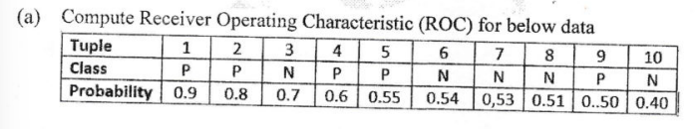

Me ye class me sikha dunga video dekha hu mast sa

**2. Explain Bayesian belief Network using suitable examples with its advantages and applications.**

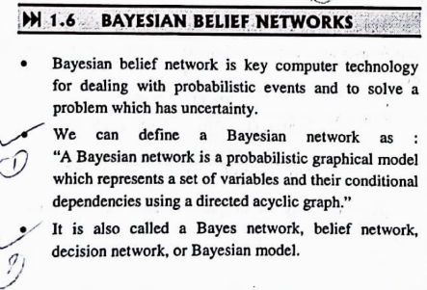

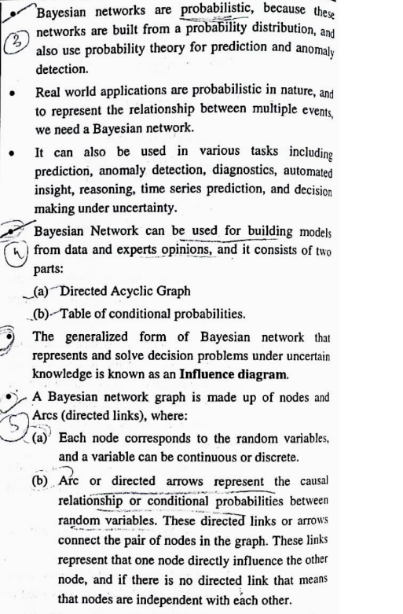

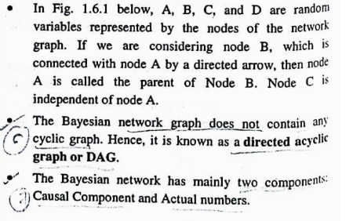

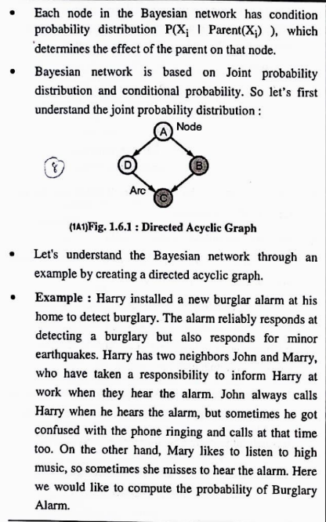

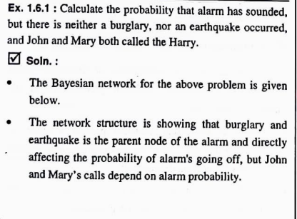

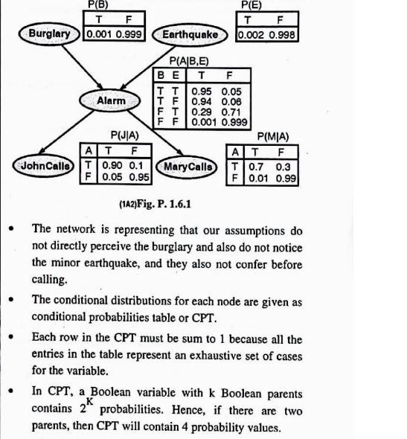

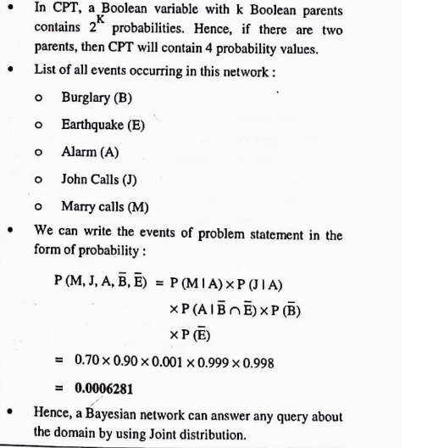

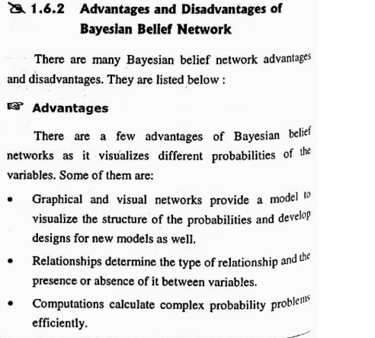

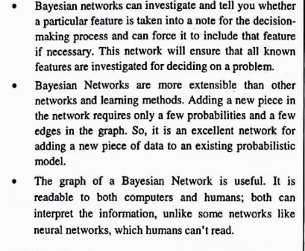

**3. Design a Fuzzy Logic Controller System for microwave oven.**

Khud se hi kuch toh banana padega on the spot  
Input: Food Type(Frozen, Solid, Liquid) & Weight(light, medium, heavy)  
Output: Time to cook(Shashwat) or Microwave Power levels(GPT)

**4. How can we represent knowledge in taxonomies and ontologies in Cognitive system.**

**State is the condition of a system at a particular point in time or in a specific situation.**

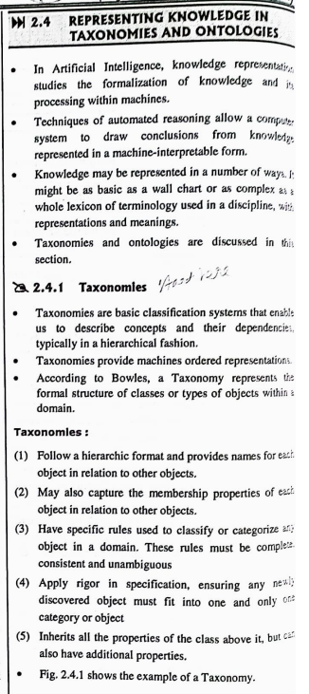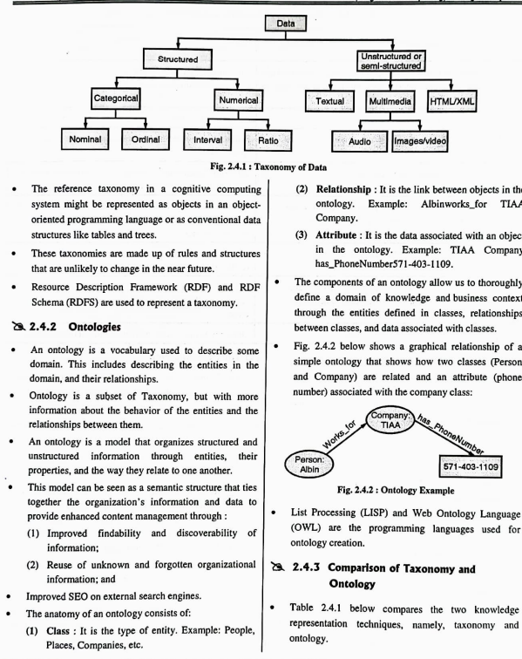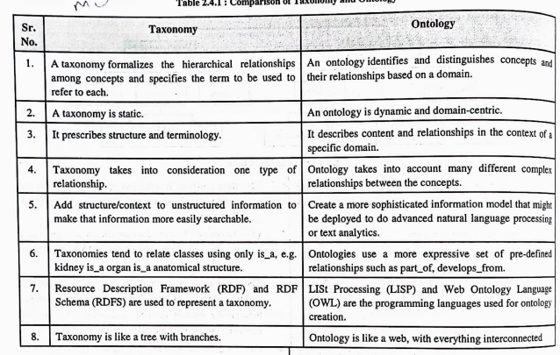

**IMP Topics**

**Chp1**

→ BBN solving

→ Decision theory

**Chp2**

→ NLP & Phases in NLP

→ Taxonomy & Ontology

→ Elements of Cognitive computing

→ Design principles of Cognitive computing

→ Steps to build a cognitive appln

**Chp3**

→ Defuzzification methods

**Chp4**

→ CNN pura

→ LSTM

→ RNN

**Chp5**

→ Ensemble methods

→ Bagging, Boosting, Stacking

→ Holdout, Random Sampling

**Chp6 (Sike that’s the wrong chapter 😉)**